**CHAPTER THREE**

**SYSTEM ANALYSIS AND DESIGN**

**3.1 The Existing System Design**

Malaria is caused by protozoan parasites of the genus *Plasmodium*. There are four species of *Plasmodium* that infect man and result in four kinds of malarial fever: *P. falciparum*, *P.*  
*vivax*, *P. ovale*, and *P. malaria*e. *P. vivax* shows the widest distribution and is characterized by reappearances of symptoms after a latent period of up to five years. With the similar characteristics, *P. ovale* appears mainly in tropical Africa. *P. falciparum* is most common in tropical and subtropical areas. It causes the most dangerous and malignant form of malaria without relapses and contributes to the majority of deaths associated with the disease. *P. malariae* is also widely distributed but much less than *P. vivax* or *P.* *falciparum* (Robertson 2009). There are three phases of development in the life cycle of most species of plasmodium:

1. *exoerythrocytic stages* in the tissues, usually the liver;
2. *erythrocytic schizogony* (i.e. protozoan asexual reproduction) in the erythrocytes;
3. *the sexual process*, beginning with the development of gametocytes in the host and continuing with the development in the mosquito.

According to Morgan et al., (2010) When an infected mosquito bites humans, several hundred *sporozoites* (the protozoan cells that develop in the mosquito’s salivary gland and infect new hosts) may be injected directly into the blood stream, where they remain for about 30 min and then disappear. Many are destroyed by the immune system cells, but some enter the cells in the liver. Here they multiply rapidly by a process referred to as *exo-erythrocytic schizogony*. When schizogony is completed, the cells produced by asexual reproduction in the liver termed *merozoites* are released and invade the erythrocytes. In *Plasmodium vivax* and *P. ovale*, some injected sporozoites may differentiate into stages termed *hypnozoites* which may remain dormant in the liver cells for some time before undergoing schizogony causing relapse of the disease. When the released merozoites enter erythrocytes, the erythrocytic cycle begins. This process is referred to as e*rythrocytic schizogony*. Within an erythrocyte, the parasite is first seen microscopically as a minute speck of chromatin surrounded by scanty protoplasm (Juri 2011). The plasmodium gradually becomes ring-shaped and is known as ring or immature *trophozoite.* It grows at the expense of the erythrocyte and assumes a form differing widely with the species but usually exhibiting active pseudopodia (i.e. projections of the nuclei). Pigment granules appear early in the growth phase and the parasite is known as a mature trophozoite. As the nucleus begins to divide, the parasite is known as a *schizont*. Dividing nucleus tends to take up peripheral positions and a small portion of cytoplasm gathers around each. The infected erythrocyte ruptures and releases a number of merozoites which attack new corpuscles and the cycle of erythrocytic schizogony is repeated. The infection about this time enters the phase in which parasites can be detected in blood smears.

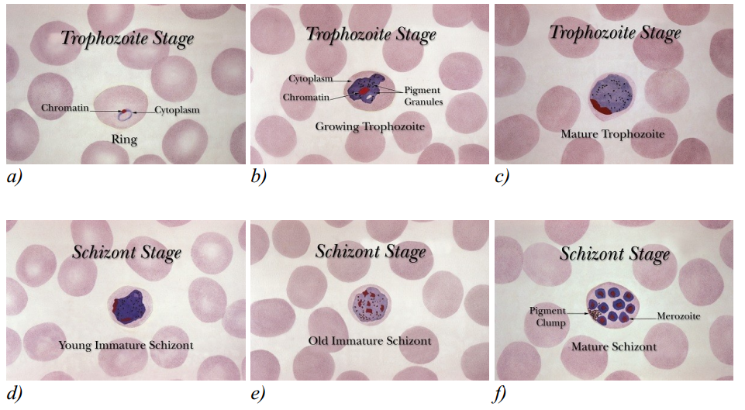

Fig 3.1 Development stages of the Plasmodium parasite

*Source: https:malariajournal.biomedcentral.com*

**3.2 Input Analysis of the Existing System**

Blood smears or blood films are microscopic slides prepared from a blood sample that allow the microscopic inspection of blood cells. Blood smears are typically used for investigation of hematological disorders and for detection of parasites, such as the Plasmodium. Two sorts of blood smears are traditionally used. Thin blood smears allow better species identification, because the appearance of the parasites is better preserved in this preparation. Thick blood smears allow screening of a larger volume of blood and, therefore, they can give more than a ten-fold increase in sensitivity over thin films. However, the appearance of the parasite is more distorted and, therefore, distinguishing between the different species can be more difficult.

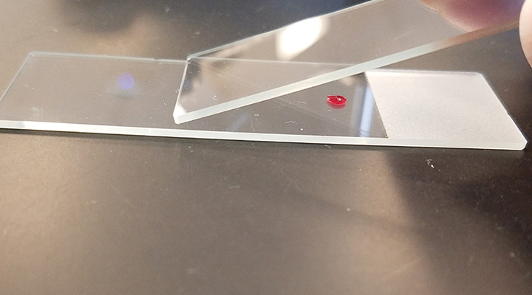

Fig 3.2 Blood smear preparation for malaria diagnosis

*Source:www.cliniciansbrief.com-diagnostic-blood-smear-preparation*

In principle, blood films are prepared by placing a drop of blood on one end or into the center of a slide and spread with the corner of another slide or a swab stick to cover an oval area along the slide. The aim is to get a region where the cells are sufficiently spread to be counted and differentiated.

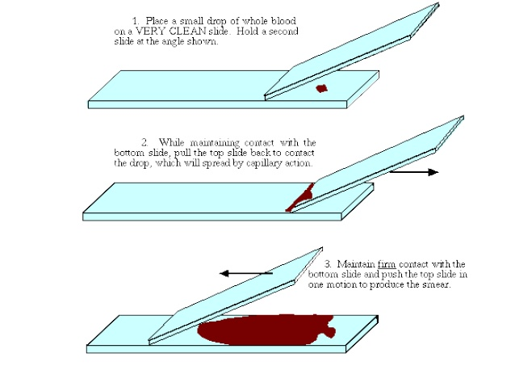

Fig 3.3 Illustration of blood smear preparation for malaria diagnosis

*Source:www.cliniciansbrief.com-diagnostic-blood-smear-preparation*

The well spread part of the blood smear, specifying the working area for microscopic analysis, is defined as a zone that starts on the body film side when red blood cells stop overlapping and finishes on the feather edge side when red blood cells start to lose their clear central zone. The smear is then thoroughly dried in an incubator at 37ºC for around one hour. The dry film can be subsequently stained using Giemsa dilution.

**3.3 Output Analysis of the Existing System**

Diagnosis of malaria involves the identification of malaria parasite in the blood samples obtained from the patient. Although this seems simple, the effectiveness of the diagnosis is subject to many factors. The microscopic tests involve staining the blood sample with Giemsa and direct visualization of the malaria parasite under the microscope. The direct microscopic visualization of the malaria parasite in the blood smears obtained from the patient has been the accepted method for the diagnosis of malaria in most settings, from the clinical laboratory to the field surveys. The careful examination of a well-prepared and well-stained blood film currently remains the gold standard for malaria diagnosis. Giemsa stain is used to differentiate nuclear and cytoplasmic morphology of platelets, red blood cells, white blood cells and parasites. Giemsa staining solution stains up nucleic acids and, therefore, parasites, white blood cells, and platelets, which contain DNA, are highlighted in a dark purple color. Red blood cells are usually colored in slight pink colors (Cabezos 2012).

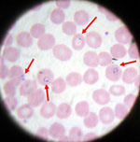

Fig 3.4 Manual diagnosis of malaria in blood smear

*Source:www.cliniciansbrief.com-diagnostic-blood-smear-preparation*

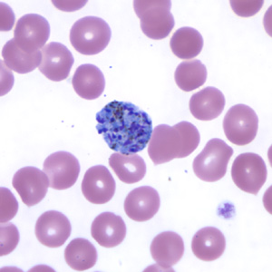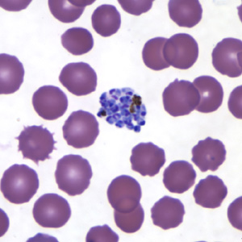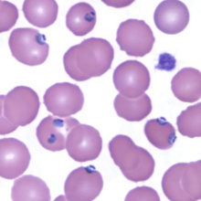

Fig 3.5 Samples of already stained blood smear images showing malaria parasites in the RBCs

*Source: Faith Mediplex, Airport Road, GRA, Benin City, Edo State.*

These images of Giemsa stained blood smears above (Fig 3.2) were gotten from the Faith Mediplex hospital laboratory and they have the following common characteristics:

* The Images are available in different magnifications and sizes. The images are available in TIFF and JPEG format with the resolution of 2 to 3 megapixels
* Digital images are obtained by scanning and, therefore, contain a part of the noise and artifact from the sample and from the microscope light also noise from the chemical development process or from the scanner.
* The Images exhibit high variability in color tone, intensity, contrast, and illumination.

The output of the existing system is usually a laboratory report on the malaria test. Clinical findings are confirmed and documented using a laboratory report. In addition to ordering the malaria specific diagnostic tests described below, the health-care provider should conduct an initial workup and request a complete red blood cell count and a routine chemistry panel. In the scenario that the person does have a positive malaria test, these additional tests will be helpful in determining whether the patient has uncomplicated or severe manifestations of the malaria infection. Specifically, these tests can detect severe anemia, hypoglycemia, renal failure, hyperbilirubinemia, and acid-base disturbances (Scribd 2010). The information contained in the lab report includes the following:

1. The name of the Laboratory
2. The name of the patient
3. The patient’s age
4. The nature of test carried out
5. Red Blood Cells count
6. Presence of the Malaria parasite
7. Type of Malaria parasite present
8. Summary of the test result
9. Other observations made during the test
10. Etc.

Below is a sample of a Malaria diagnosis laboratory report:

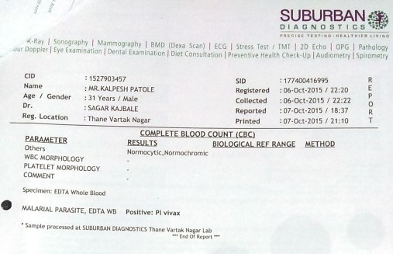

Fig 3.6 A malaria diagnosis laboratory report

*Source: https://www.ncbi.nlm.nih.gov/pmc/articles/PMC5396426/*

**3.4 Flowchart of the Existing System**

The first suspicion of malaria is usually based on clinical criteria, especially fever or a recent history of fever; however, even in areas of high transmission, most cases of fever are usually not due to malaria. As the clinical manifestations of malaria are nonspecific, a diagnosis based on clinical symptoms alone results in a high number of false-positive results; often, other diseases are overlooked or not treated in a timely manner, contributing to significant morbidity and mortality due to non-malaria illness. False-positive results also lead to misuse of antimalarial drugs, exposure of parasites to sub-therapeutic blood levels of the drugs and development of resistance, increased costs to the health services and patient dissatisfaction.

An accurate laboratory diagnosis is essential, as false-negative results can lead to untreated malaria and potentially severe consequences, including death. False-negative results can also significantly undermine both clinical confidence in laboratory results and the credibility of the health services within a community. The flowchart shows how information flows from one point to another during the diagnosis and subsequent treatment of malaria in an infected patient.

Below is the information flow diagram:

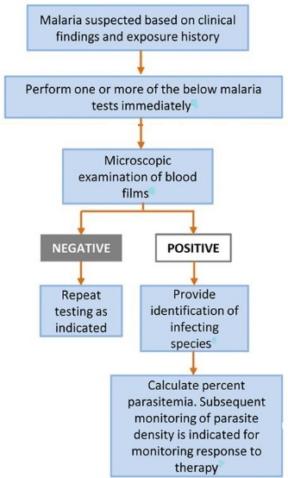

Fig 3.7 A typical Malaria diagnosis flowchart

*Source:* [*https://www.ncbi.nlm.nih.gov/pmc/articles/PMC5396426/*](https://www.ncbi.nlm.nih.gov/pmc/articles/PMC5396426/)

**3.5 Limitations of the Existing System**

The accuracy of the diagnosis of malaria using the existing system depends on the availability of a competent pathologist using good-quality reagents for examining well-prepared slides under a well-maintained microscope with an adequate light source and with a low-to-moderate workload. It has therefore been difficult in some cases to maintain a good standard of malaria diagnosis, especially in rural areas, where over 60% of malaria cases occur. The factors that limit the availability and quality of the existing system include:

* Lack of resources to provide all laboratories with equipment and good-quality reagents for microscopy
* Lack of programs and resources for training and continuous improvement of the competence of pathologists
* Difficulty in maintaining microscopy facilities in good order and lack of microscope maintenance capability
* Lack of electricity, water and suitable laboratory facilities in some areas
* Logistical problems and high costs of maintaining adequate supplies and equipment
* Lack of national malaria slide banks for building and monitoring competence
* Absence of a national system to certify the level of competence of pathologists
* Heavy workloads, which delay the provision of results to clinical staff
* Weak supervision of laboratory services and lack of remedial action
* Inability to cope with the workload of cross-checking routine malaria slides, often due to inadequate human and financial resources
* Lack of an internal Quality Control system, particularly in private medical laboratories
* Decreasing practice of malaria microscopy in some settings because of extensive deployment of RDTs (Rapid Diagnostic Test) and fewer positive cases after a reduction in the malaria burden.

**3.6 Objectives of The New System**

The manual inspection and analysis of slides is, however, laborious, time-consuming and requires a skilled and well-trained operator. Moreover, the accuracy of the final diagnosis is subject to the skill and the experience of the technician and the time spent studying each slide. The main objective of the new system is to be able to determine the presence of the malaria parasites in Geimsa stained blood smears. Other objectives include the following;

• To reduce the chance of omission or false detection due to human error.

• To facilitate the accurate and timely diagnosis of malaria infection.

• To help in battling malaria outbreaks where hundreds of blood samples may need to be tested quickly and accurately.

In this context, the development of a mechanism that automates the process of evaluation, quantification and classification in blood samples becomes a high priority and the aim of this work was to contribute to improvement upon malaria microscopy diagnosis by removing the reliance on the performance of a human operator for diagnostic accuracy. A number of methods have been proposed for automatic parasite detection in Giemsa stained blood films based on different approaches. These approaches include pixel-based parasite detection, detection based on morphological processing of segmented parasites, or detection by extracting image features using convolutional neural networks. In this work, detection of malaria parasites in blood smears is based on the last approach which is the use of convolutional neural networks.

**3.7 Justification of the New System**

The limitations and shortcomings of the existing system has already been described, related to sensitivity, specificity, accuracy, precision, time consumption, cost-effectiveness, labor intensiveness, the need for skilled pathologists and the problem of inexperienced technicians. In view of the problems present in the existing system, it is important to seek for an improvement. This improvement is computerization of the diagnosis system. This new automated system will have the following advantages:

1. Digitization of Output: The output is an analyzed image of the blood sample and the parasites found in the blood sample are detected by the computer within seconds.
2. Simpler and faster Diagnosis: It will be possible to check more blood samples faster, as protracted visual checks are replaced by fast computers.
3. Reliability: Contrary to a human eye, cameras and computers never get tired. The human factor is eliminated; you will not notice any fluctuations in reliability based on how your controllers slept that day or what day of the week it is.
4. Accuracy: The automated diagnosis has a very high accuracy due to the elimination of possible human error.
5. Reduction of costs: Automated diagnosis is relatively cheaper to implement that manual diagnosis.
6. Availability: The ability of running the automated diagnosis 24 hours a day and the machine is always there to render services.
7. Higher Quality: Machine vision technology is unique in its ability to resolve the trade-off between raising quality and cutting costs.

**3.8 The New System Design**

A number of new methods have been developed in recent years for the diagnosis of malaria. These include the use of fluorescent microscopy, rapid antigen detection methods and polymerase chain reaction (PCR) - based techniques that detect specific nucleic acid sequences. Despite these advances, malaria diagnosis by means of manual microscopy remains the most widely and commonly used method. Usually, these jobs are conducted by experienced pathologists manually. Microscopic diagnosis entails examining blood smears for the presence of Plasmodia. Unfortunately, there are also disadvantages to the method: substantial costs are incurred purchasing and maintaining microscopes and training technicians, the technique is labor intensive and time-consuming and the accuracy of the final diagnosis relies on the skill and experience of the technician and the time spent studying each slide. Variable smear quality and slide degeneration with time are also problematic. In this research, we proposed an automated system based on supervised machine learning to detect malaria plasmodium which is able to eliminate the most important limits of microscopic method, that is:

1. Time-consuming and tiring job
2. Low accuracy even in experts.

Here in this research we mainly focus on the task of determining the presence of the parasites and highlighting them for ease of identification, because it is the most essential and time-consuming step in the diagnosis of malaria. Also, we propose a motorized microscope which is fully matched with image processing procedure to make the whole diagnosis process automatic. Furthermore, it means that the physician just puts the blood smear under the lens of microscope and runs the system; after a few minutes the report, which includes the number of RBCs and parasites, is issued.

**3.9 Flowchart of the New System**

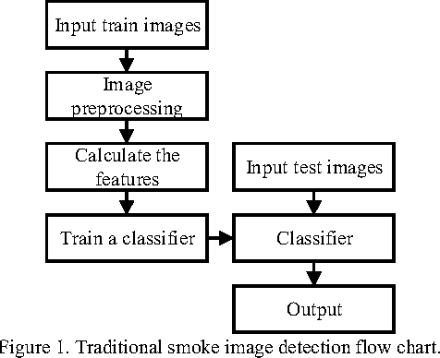

Fig 3.8 Flowchart of the new system

*Source: My computer/Photoshop Express*

An automated diagnostic method can be developed by understanding the diagnostic process and implementing it using a machine learning algorithm. The machine learning algorithm should perform diagnosis more or less imitating the manual microscopy. The developed algorithm should be capable of functioning in an unsupervised environment and should be robust with minimal false negatives (leading to high sensitivity). The unsupervised nature of the proposed machine learning diagnostic method should reduce human intervention, and in so doing speed up the diagnosis process. The machine learning algorithm must also be sensitive enough to detect malaria parasites at all stages particular at the early stages of their life cycle and must be capable of doing this without missing any parasite irrespective of image variations. In order to perform diagnosis, the method must be capable of differentiating between malaria parasites and artefacts.

**3.10 Requirements for the New System**

The first requirement in this research is blood smears which are Giemsa stained microscopic slides prepared from blood samples that allow microscopically examinations of blood cells. Thin blood smears allow better species identification, because the appearance of the parasites is better preserved in this preparation. Thick blood smears allow screening of a larger volume of blood, therefore, they can give more than a ten-fold increase in sensitivity over thin films. In this research, morphological properties are important for us, hence we used thin films. For effective malaria diagnosis, blood films should be prepared as fast as possible after blood samples are taken. Such films adhere better to the slides; leave a clearer background after drying, thus, parasite and red cell changes are minimal. After preparing blood films they should be examined by a microscope.

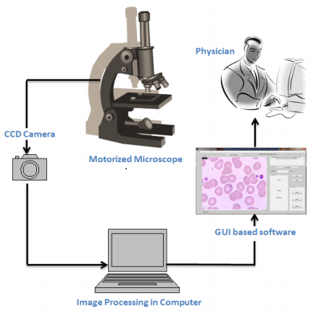

Fig 3.9 Overall scheme of proposed Malaria diagnosis system

*Source: https://www.vinodsblog.com*

A microscope is equipped with two stepper motors which move the blood samples under lens quite smoothly. The amount of movement in each direction is calculated by a microcontroller installed on the microscope board to avoid taking overlapped photos. This also helps avoid calculating each RBC more than once. The photos taken by CCD are transmitted to the image processing program running on a computer. RBCs and infection are detected simultaneously and the final report is issued.

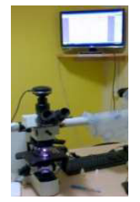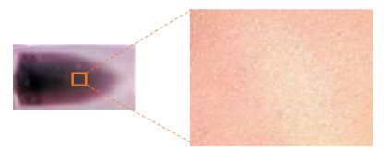

Fig 3.11 Thin blood smear slide and acquired digital microscope image at 40X magnification.

*Source: www.semanticscholars.com*

Fig 3.10 Camera attached to Microscope for acquiring images of blood samples

*Source: Faith Mediplex Hospital Laboratory*

The images recorded with the magnification of 1000X are indicates parasite clearly. The Olympus DP25 digital camera of 5 MP attached to the light microscope Olympus BX51, which is connected with the computer, along with the user interface software (DP2 BSW) are shown in Figure 3.10. The acquired the blood image from the focused slide area are collected. The typical malarial thin blood smear image acquired at 40X magnification is shown in the Figure 3.11. Blood images acquired with the various magnifications such as 100X, 200X, 400X and 1000X are shown respectively in the Figures 3.12 A-D. A total of 1,160 images were considered for classification of malarial and non-malarial classes. The acquired thin blood smear image has red blood corpuscles (RBC), malarial parasites, Platelets and other objects. But the proposed technique focus on diagnosis of malaria is based on examination of RBCs, since the malarial parasite infects the RBC.

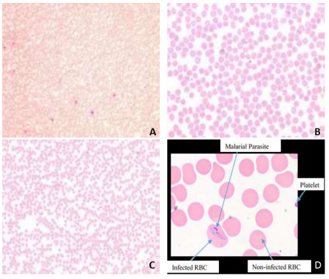

Fig 3.12 The magnified microscopic blood images of the blood sample: (a) at 100X; (b) 200X; (c) 400X; (d) 1000X

*Source: https://www..machinecurve.com/malaria-diagnosis-and-computer-vision*